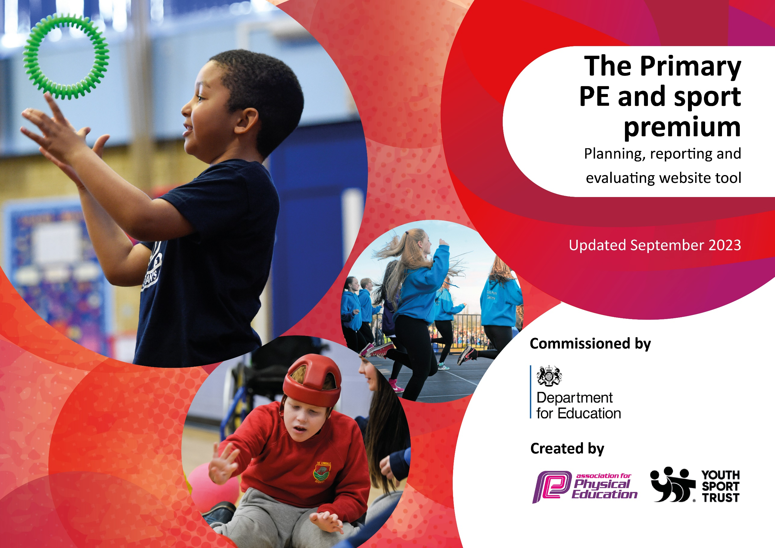

guidance, outlines 5 key priorities that funding should be used towards. It is not

Review of last year’s spend and key achievements (2023/2024)

We recommend you start by reflecting on the impact of current provision and reviewing your previous spend.

Activity/Action | Impact | Comments
Subscription to Get Set 4 PE scheme to support planning and assessment of PE throughout the school.  New equipment purchased to facilitate the delivery of the new PE planning, update old and broken equipment and add additional sports to the curriculum including Handball and Badminton.  New equipment purchased for lunchtime and playtimes to encourage active play.  Specialist coaches employed to run after school activities to widen the offer including reforming the Clanfield football Team.  Sports specialist employed to mentor teachers in the delivery of games lessons.  Sports leaders trained by Specialist sports coaches in preparation for next year. | PE lessons are more effectively structured with a clear progression of skills across the Key stage.  Teachers are more confident in their delivery of lessons due to clear and detailed planning with advice of setup and equipment needed.  Sports changed to meet need and offer variety including the introduction of Handball into the curriculum offer.  Lessons run more smoothly as suitable correct equipment available to be used including two new basket ball hoops.  Children are more active at lunchtimes and more imaginative in their play due to the variety of available equipment.  Children’s engagement in sport has increased both during lunchtimes and after school with after school clubs regularly over-subscribed.  Teachers show more confidence in their delivery of outdoor games and teaching is improved.  More structured activity offered at lunchtimes to increase physical activity this had some impact on children not engages in play. | GetSEt4PE continues to be used and rated as very useful by all teachers.  Audit carried out and equipment purchase with support of Specialist PE teacher to advise.  Some equipment is not used correctly – play leaders to demonstrate uses of new equipment.  Move to tracking clubs in 24-25 to idenfity those children not engaged and work to further engage these groups.  Majority teachers in the school have had one round of mentoring and report increased confidence in teaching games lessons.  Set year groups to be introduced next year to support play-leaders in reaching all ages of children.

Swimming Data
Meeting National Curriculum requirements for swimming and water safety.
Priority should always be given to ensuring that pupils can perform safe self-rescue even if they do not fully meet the first two requirements of the National Curriculum programme of study

Question | Stats: | Further context  Relative to local challenges
What percentage of your current Year 6 cohort can swim competently, confidently and proficiently over a distance of at least 25 metres? | 90% | Swimming lessons took place at Petersfield pool for Year 5 children.  12 weeks of lessons.
What percentage of your current Year 6 cohort can use a range of strokes effectively [for example, front crawl, backstroke, and breaststroke]? | 86%

What percentage of your current Year 6 cohort are able to perform safe self-rescue in different water-based situations? | 80%
If your schools swimming data is below national expectation, you can choose to use the Primary PE and sport premium to provide additional top-up sessions for those pupils that did not meet National Curriculum  requirements after the completion of core lessons. Have you done this? | No
Have you provided CPD to improve the knowledge and confidence of staff to be able to teach swimming and water safety? | No | Swimming taught by qualified coaches at Petersfield pool.

Signed off by:

Head Teacher: | Kate Lawrence
Subject Leader or the individual responsible for the Primary PE and sport premium: | Adam Chant
Governor:
Date: 31.7.24

